**Database Design**

Database design is quite important to the system because it defines the structure of the system. This logical data model contains all the needed logical and physical design choices and physical storage parameters needed to generate a design in a Data Definition Language, which can then be used to create a database.

Normalization in database design was used to reduce data redundancies. Database normalization is a design technique for structuring relational database tables. Database theory describes a table's degree of normalization in terms of normal forms. The database was normalized in the third normal form (3NF). Figure 24 presents the database snowflake and Figure 25 shows the database dictionary of the system which guided the researcher in the development of the system.

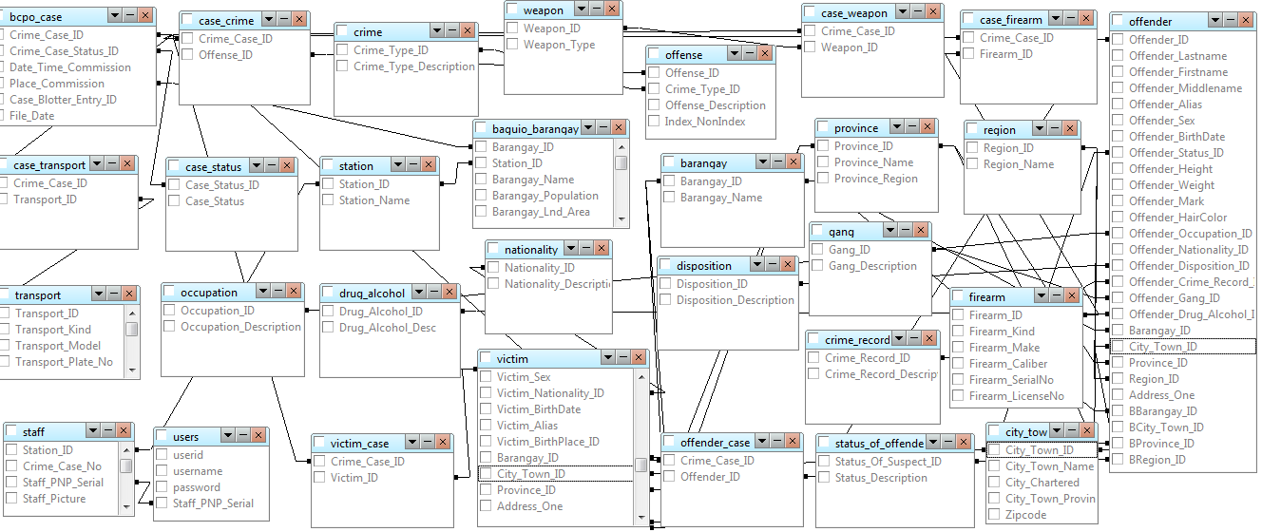

Database Snowflake

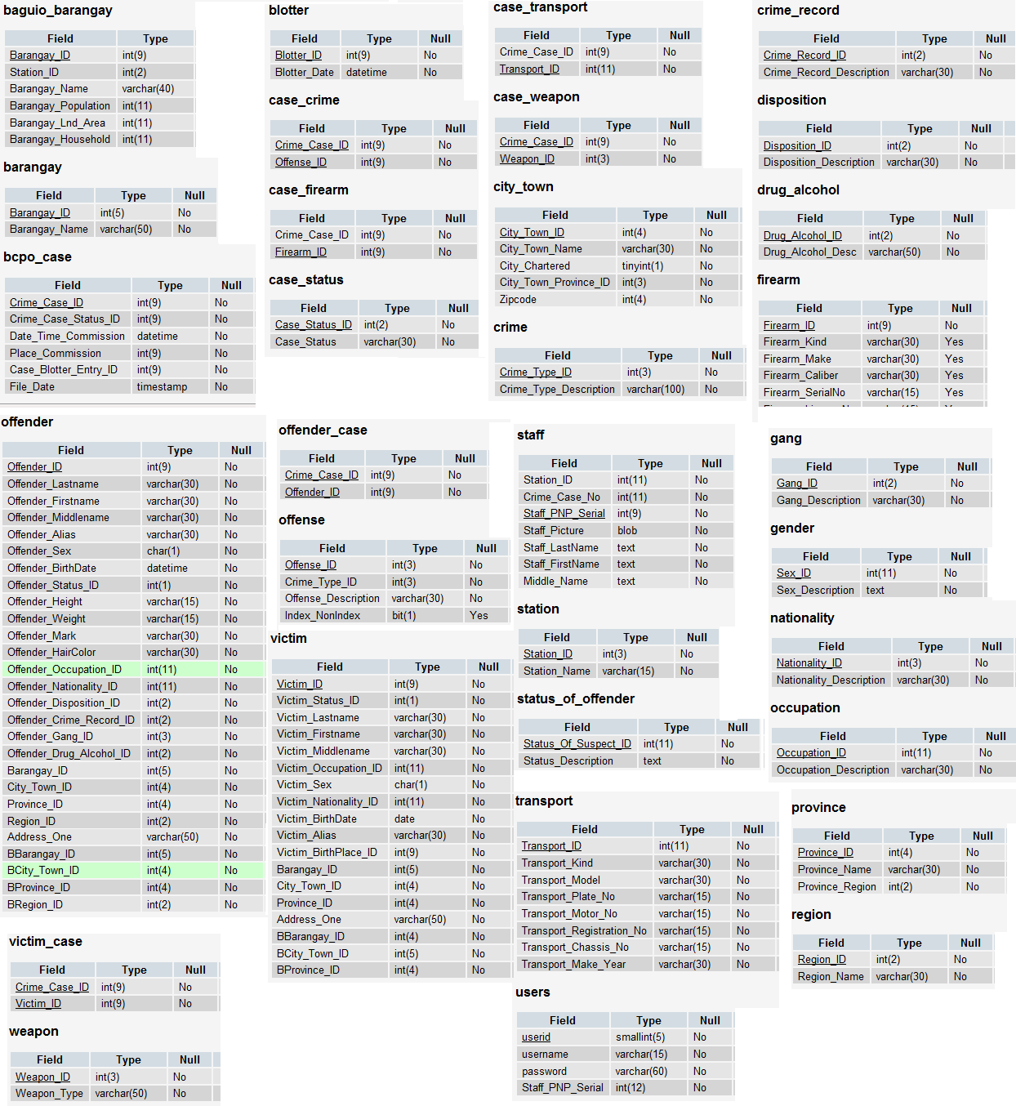

Data Dictionary